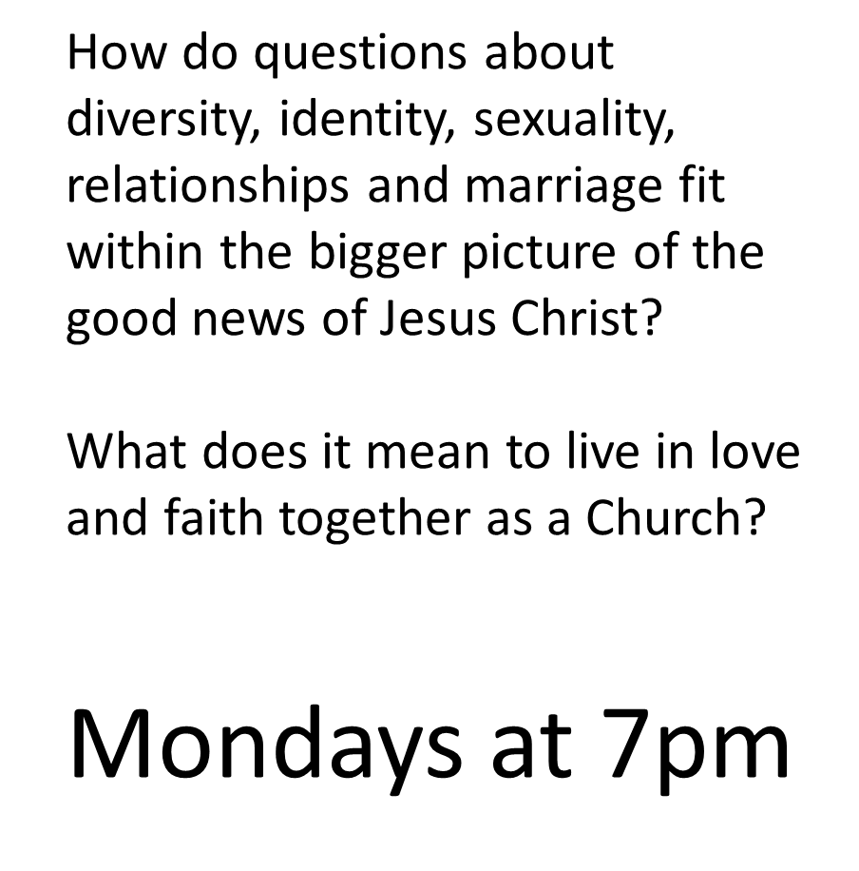

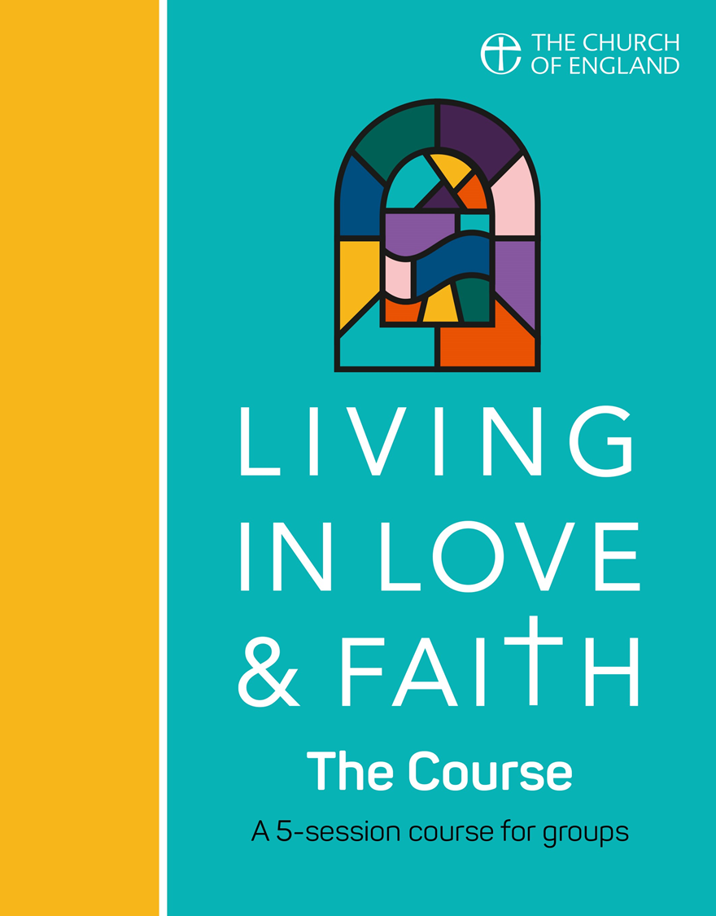

**CONVERSATIONS TOGETHER**

How do questions about diversity, identity, sexuality, relationships and marriage fit within the bigger picture of the good news of Jesus Christ?

What does it mean to live in love and faith together as a Church?

Mondays at 7pm through

September